MongoDB Result Images

# The sample data’s and collection:

Users:

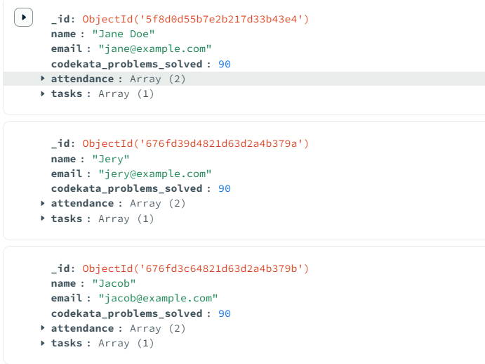

Tasks: 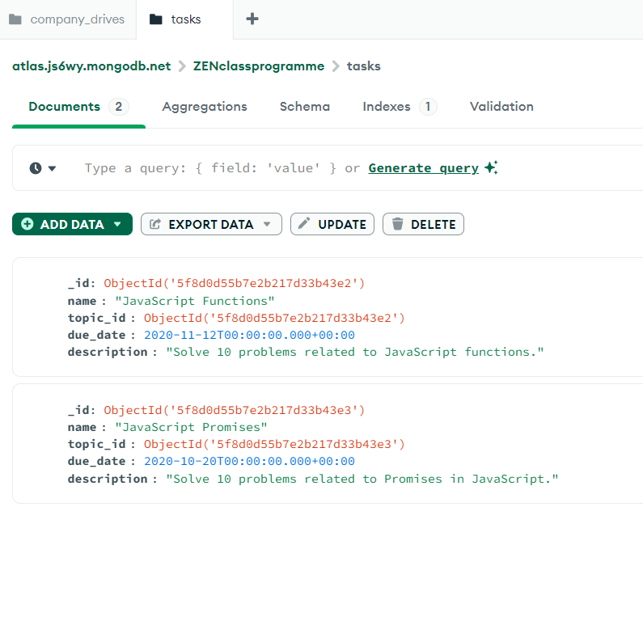

Mentors: 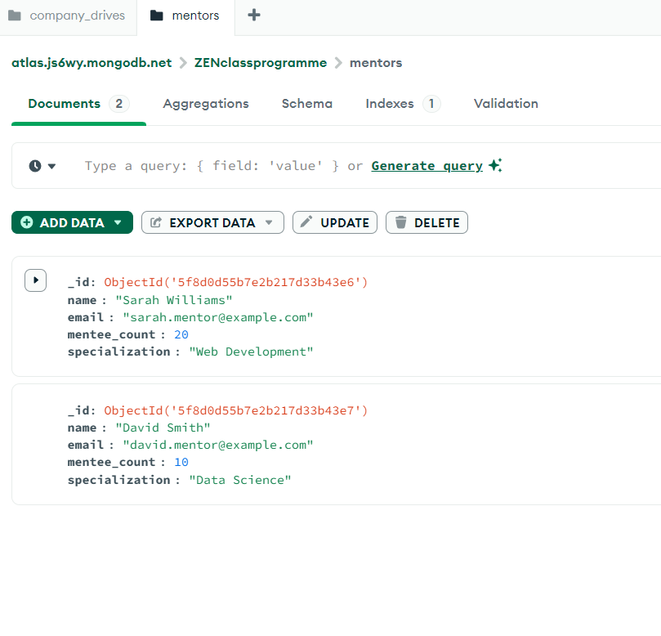

Company Drives: 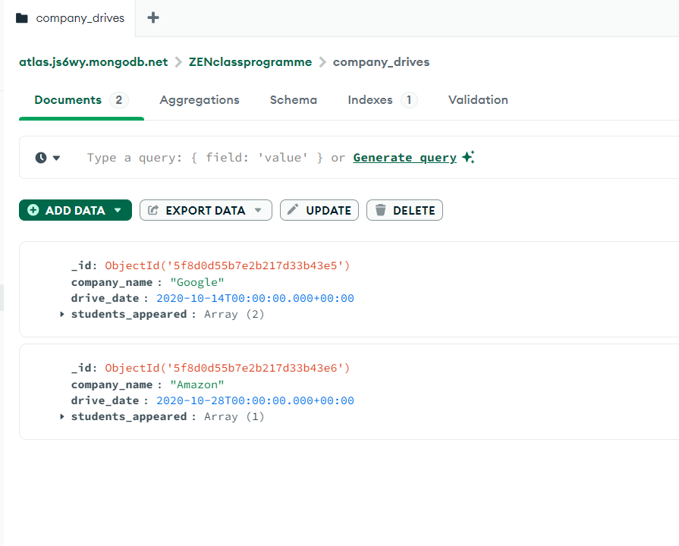

Topics: 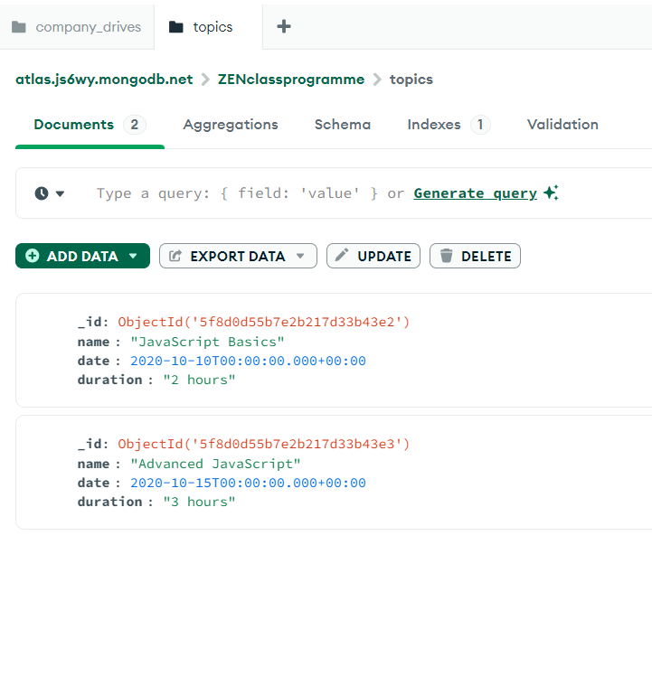

EVERY Query Answer:

## First Query:

1. Find all the topics and tasks which are thought in the month of October

{

_id: ObjectId('5f8d0d55b7e2b217d33b43e2'),

name: 'JavaScript Basics',

date: 2020-10-10T00:00:00.000Z,

duration: '2 hours',

tasks: [

{

_id: ObjectId('5f8d0d55b7e2b217d33b43e2'),

name: 'JavaScript Functions',

topic_id: ObjectId('5f8d0d55b7e2b217d33b43e2'),

due_date: 2020-11-12T00:00:00.000Z,

description: 'Solve 10 problems related to JavaScript functions.'

}

]

_id: ObjectId('5f8d0d55b7e2b217d33b43e3'),

name: 'Advanced JavaScript',

date: 2020-10-15T00:00:00.000Z,

duration: '3 hours',

tasks: [

{

_id: ObjectId('5f8d0d55b7e2b217d33b43e3'),

name: 'JavaScript Promises',

topic_id: ObjectId('5f8d0d55b7e2b217d33b43e3'),

due_date: 2020-10-20T00:00:00.000Z,

description: 'Solve 10 problems related to Promises in JavaScript.'

}

]

}

## 2nd Query:

Find all the company drives which appeared between 15 oct-2020 and 31-oct-2020

# Query:

db["company_drives"].find({

  drive_date: {

    $gt: ISODate("2020-10-15T00:00:00Z"),

    $lt: ISODate("2020-10-31T23:59:59Z")

  }

})

# RESULT:

{

_id: ObjectId('5f8d0d55b7e2b217d33b43e6'),

company_name: 'Amazon',

drive_date: 2020-10-28T00:00:00.000Z,

students_appeared: [

ObjectId('5f8d0d55b7e2b217d33b43e4')

]

}

# 3rd Query:

Find all the company drives and students who are appeared for the placement.

## Query:

db.company_drives.aggregate([

  {

    $lookup: {

      from: "users",

      localField: "students_appeared",

      foreignField: "_id",

      as: "students"

    }

  }

])

# RESULT:

{

_id: ObjectId('5f8d0d55b7e2b217d33b43e5'),

company_name: 'Google',

drive_date: 2020-10-14T00:00:00.000Z,

students_appeared: [

ObjectId('5f8d0d55b7e2b217d33b43e1'),

ObjectId('5f8d0d55b7e2b217d33b43e4')

],

students: [

{

_id: ObjectId('5f8d0d55b7e2b217d33b43e1'),

name: 'John Doe',

email: 'john@example.com',

codekata_problems_solved: 150,

attendance: [

{

date: 2020-10-15T00:00:00.000Z,

status: 'absent'

},

{

date: 2020-10-16T00:00:00.000Z,

status: 'present'

}

],

tasks: [

{

task_id: ObjectId('5f8d0d55b7e2b217d33b43e2'),

submitted: false

},

{

task_id: ObjectId('5f8d0d55b7e2b217d33b43e3'),

submitted: true

}

]

},

{

_id: ObjectId('5f8d0d55b7e2b217d33b43e4'),

name: 'Jane Doe',

email: 'jane@example.com',

codekata_problems_solved: 90,

attendance: [

{

date: 2020-10-15T00:00:00.000Z,

status: 'present'

},

{

date: 2020-10-16T00:00:00.000Z,

status: 'present'

}

],

tasks: [

{

task_id: ObjectId('5f8d0d55b7e2b217d33b43e2'),

submitted: true

}

]

}

]

}

{

_id: ObjectId('5f8d0d55b7e2b217d33b43e6'),

company_name: 'Amazon',

drive_date: 2020-10-28T00:00:00.000Z,

students_appeared: [

ObjectId('5f8d0d55b7e2b217d33b43e4')

],

students: [

{

_id: ObjectId('5f8d0d55b7e2b217d33b43e4'),

name: 'Jane Doe',

email: 'jane@example.com',

# codekata_problems_solved: 90,

attendance: [

{

date: 2020-10-15T00:00:00.000Z,

status: 'present'

},

{

date: 2020-10-16T00:00:00.000Z,

status: 'present'

}

],

tasks: [

{

task_id: ObjectId('5f8d0d55b7e2b217d33b43e2'),

submitted: true

}

]

}

]

}

# 4th QUERY:

Find the number of problems solved by the user in codekata

# QUERY:

db["users"].find({},{codekata_problems_solved:1, name:1})

# RESULT:

{

_id: ObjectId('5f8d0d55b7e2b217d33b43e1'),

name: 'John Doe',

codekata_problems_solved: 150

}

{

_id: ObjectId('5f8d0d55b7e2b217d33b43e4'),

name: 'Jane Doe',

codekata_problems_solved: 90

}

{

_id: ObjectId('676fd39d4821d63d2a4b379a'),

name: 'Jery',

codekata_problems_solved: 90

}

_id: ObjectId('676fd3c64821d63d2a4b379b'),

name: 'Jacob',

codekata_problems_solved: 90

}

# 5th Query:

Find all the mentors with who has the mentee's count more than 15

## QUERY:

db["mentors"].find({mentee_count:{$gt:15}});

## Result:

{

_id: ObjectId('5f8d0d55b7e2b217d33b43e6'),

name: 'Sarah Williams',

email: 'sarah.mentor@example.com',

mentee_count: 20,

specialization: 'Web Development'

}

# 6th QUERY:

Find the number of users who are absent and task is not submitted  between 15 oct-2020 and 31- oct-2020

# QUERY:

db.users.aggregate([

  {

    $unwind: "$attendance"

  },

  {

    $match: {

      "attendance.date": { $gte: ISODate("2020-10-15T00:00:00Z"), $lte: ISODate("2020-10-31T23:59:59Z") },

      "attendance.status": "absent"

    }

  },

  {

    $lookup: {

      from: "tasks",

      localField: "_id",

      foreignField: "user_id",

      as: "tasks"

    }

  },

  {

    $match: {

      "tasks.submitted": false

    }

  },

  {

    $count: "absent_and_not_submitted"

  }

])

# RESULT:

{

absent_and_not_submitted: 4

}